**Machine Intelligence & Expert Systems**

**KNN Programming Assignment**

Utkarsh Patel 18EC35034

**1 Results from Hyperparameter Tuning**

**Metric Neighbors Train accuracy Test accuracy**

euclidean 1 1.0 0.957

euclidean 3 0.971 0.943

euclidean 5 0.967 0.943

euclidean 7 0.967 0.943

norm-euclidean 1 0.989 0.914

norm-euclidean 3 0.97 0.929

norm-euclidean 5 0.96 0.957

norm-euclidean 7 0.957 0.971

cosine 1 1.0 0.943

cosine 3 0.94 0.914

cosine 5 0.927 0.914

cosine 7 0.921 0.914

**2 Best Performing Hyperparameter**

It can be observed from the above table, maximum test accuracy is achieved using seven nearest neighbors for normalized Euclidean distance.

**3 Analysis of Results**

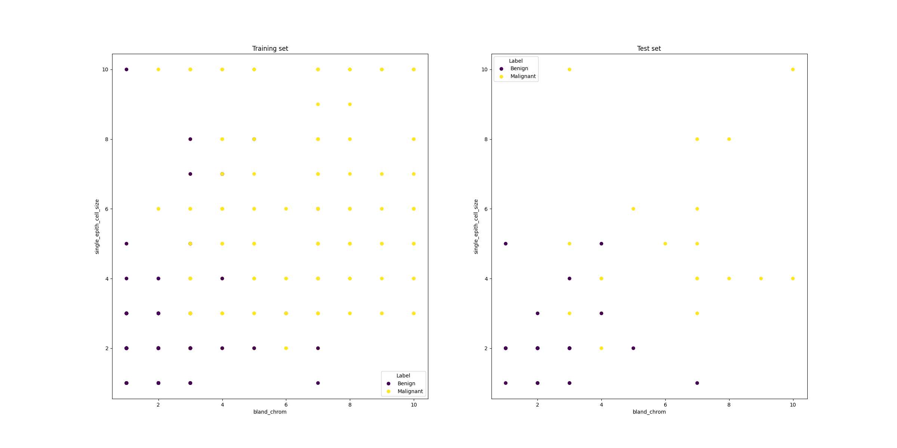

**Fig.** Scatter plot of training set and test set

It can be observed from the above table, the training accuracy and the test accuracy reduces as we increase number of neighbors to make prediction for Euclidean and cosine metrics, and reverse is observed for normalized Euclidean metric. The maximum test accuracy is achieved using seven nearest neighbors for normalized Euclidean distance.